# TNE30023 Advanced Switching Case Study

TNE30023 Advanced Switching Case Study 1

Team Members 1

Show Commands 3

Trunks and Port Channels 4

sh Int Tru 4

sh etherchannel sum 5

VTP 8

sh vtp status 8

VLANs 10

sh vlan br 10

Spanning Tree (STP) 12

sh span mst conf 12

sh span root 13

sh run | section span 16

SVIs 18

sh ip int br | exclude assigned 18

HSRP 19

sh stand br 19

sh run | section track 20

Routing 21

sh ip route 21

DHCP 24

sh ip dhcp snooping 24

sh run | section ip dhcp relay 25

Port Security 25

sh port-security 25

ACLs 26

sh access-list 26

sh ip int | include line | list 29

VACL 34

sh run | section vlan access-map 34

sh run | section vlan filter 35

SSH 35

sh ip ssh 35

sh run | section line vty 36

NTP 36

sh ntp status 36

sh ntp association 37

Private VLANs 38

sh vlan private-vlan 38

sh vlan private-vlan type 38

Test connectivity to Internet 38

ping 200.200.10.5 38

# Show Commands

|  |  |  |
| --- | --- | --- |
| Section | Device/s | Commands |
| Trunks and Port Channels | All Switches | sh int tru |
|  | All Switches | sh etherchannel sum |
| VTP | All Switches | sh vtp status |
| VLANs | All Switches | sh vlan brief |
| Spanning Tree (STP) | All Switches | sh span mst conf |
|  | All Switches | sh span root |
| Spanning Enhancements | All Switches | sh run | section span |
| SVIs | All Switches | sh ip int br | exclude assigned |
| HSRP | DLS1 & 2 | sh stand br |
|  | DLS1 & 2 | sh run| section track |
| Routing | R, DLS1 & 2 | sh ip route |
| DHCP Snooping | ALS1 & 2 | s hip dhcp snooping |
|  | DLS1 & 2 | sh run | section ip dhcp relay |
| Port Security | ALS1 & 2 | sh port-security |
| ACLs | ALS1, DLS1 & 2 | sh access-list |
|  | ALS1, DLS1 & 2 | s hip int | include line | list |
| VACL | ALS1 | sh run | section vlan access-map |
|  | ALS1 | sh run | section vlan filter |
| SSH | R | sh ip ssh |
|  | R | sh run | section line vty |
| NTP | All Switches | sh ntp status |
|  | All Switches | sh ntp association |
| Private VLANs | DLS2 | sh vlan private-vlan |
|  | DLS2 | sh vlan private-vlan type |
| Test connectivity to Internet | ALS1 & ALS2 | ping 200.200.10.5 |

## Trunks and Port Channels

### sh Int Tru

These outputs show all the active trunks on the switches and their statuses. It shows that all the trunks are port channels for the switches. It also shows that the native VLAN for each of these is VLAN 800. This means that by default, untagged traffic will be put into VLAN 800 when going through the trunks listed in the screenshots.

#### ALS1

#### ALS2

#### DLS1

#### DLS2

### sh etherchannel sum

These outputs show all the active EtherChannels and the status of the logical interfaces and the physical interfaces. All the ports listed with ‘P’ e.g. Fa0/2(P), means that the port is part of a port channel. Port channel 1 and 4 are Layer 2 EtherChannels that use the PaGP negotiation protocol, while Port channel 2 and 3 are static Layer 2 EtherChannels that are not using any negotiation protocols. Port channel 10 is a Layer 3 EtherChannel that is using the LACP negotiation protocol. As seen in the outputs, all port channels are up.

#### ALS1

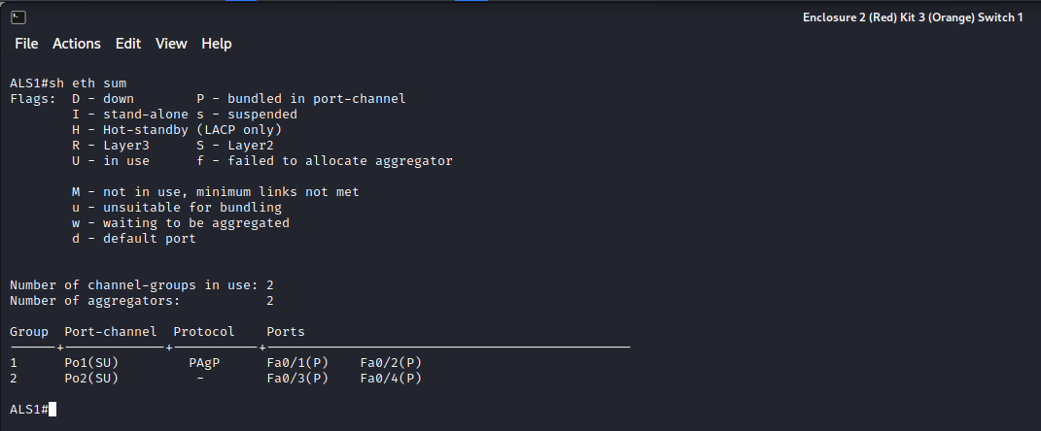

#### ALS2

#### DLS1

#### DLS2

## VTP

### sh vtp status

These outputs show that all the switches are running version 3 of VTP and are using the domain name ‘CISCO’. The switches’ VTP mode is set to transparent so that changes or new VLANs on any of the switches do not affect other switches.

#### ALS1

#### ALS2

#### DLS1

#### DLS2

## VLANs

### sh vlan br

These outputs show that the required VLANs have been created on each switch. These also show the ports each VLAN has been assigned to.

#### ALS1

#### ALS2

#### DLS1

#### DLS2

## Spanning Tree (STP)

### sh span mst conf

These outputs show that the MST instances were created correctly. MST instance 1 was created for VLANs 10 and 20. MST instance 2 was created for VLANs 100 and 110.

#### ALS1

#### ALS2

#### DLS1

#### DLS2

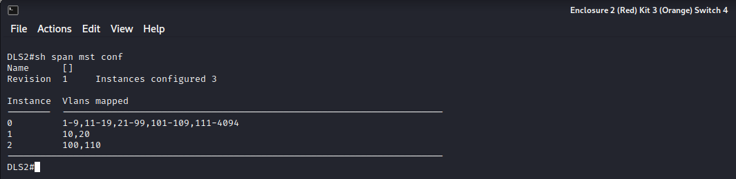

### sh span root

These outputs show that MST instances 1 and 2 have been created successfully on each switch. The output on DLS1 shows that it is the root bridge for MST instance 1 which is for VLANs 10 and 20. The output for DLS2 shows that it is the root bridge for MST instance 2 which is for VLANs 100 and 110.

#### ALS1

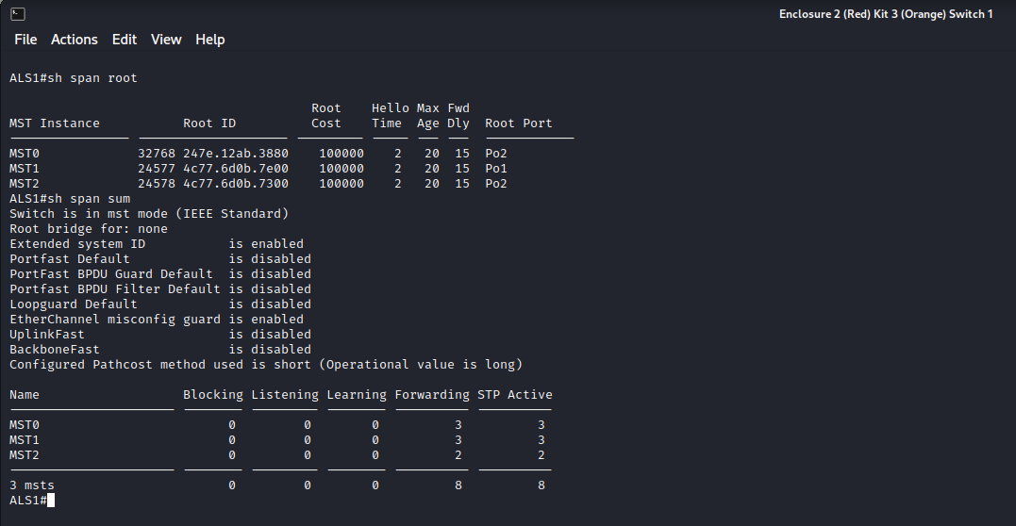

#### ALS2

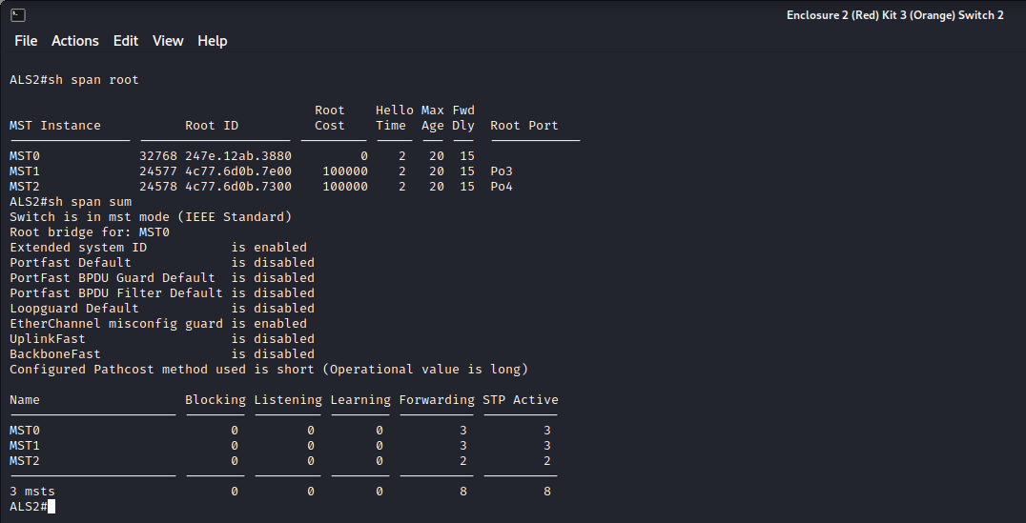

#### DLS1

#### DLS2

### sh run | section span

These outputs show that BPDU Guard and PortFast have been enabled on interfaces. This output does not show which interfaces it has been applied to. These outputs also show the spanning tree priority numbers for DLS1 and DLS2 for MST instances 1 and 2. This further shows that DLS1 is the root bridge for MST instance 1 (DLS1 has a lower priority number than DLS2 for MST1) and DLS2 is the root bridge for MST instance 2 (DLS2 has a lower priority number than DLS1 for MST2). It also shows that the spanning tree mode set on all switches is MST.

#### ALS1

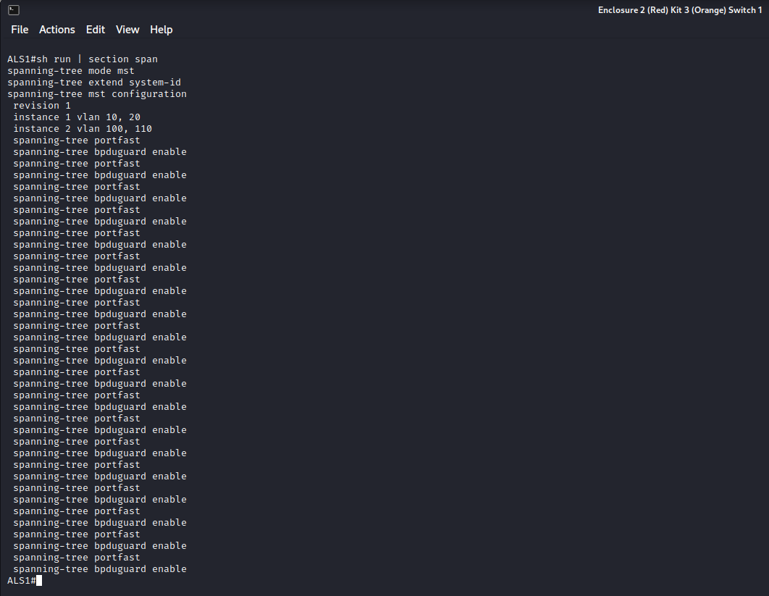

#### ALS2

#### DLS1

#### DLS2

## SVIs

### sh ip int br | exclude assigned

These outputs show the created SVIs, their IP addresses and their statuses. All required SVIs are up and have IP addresses.

#### ALS1

#### ALS2

#### DLS1

#### DLS2

## HSRP

### sh stand br

These outputs show that DLS2 is the active router for VLANs 10 and 20 and in standby state for VLANs 100, 110 and 150. DLS1 is the active router for VLANs 100, 110 and 120 and DLS2 is in standby state for VLANs 10 and 20. These outputs also show that pre-empt is configured on all SVIs of DLS1 and DLS2. This allows DLS1 and DLS2 to react to changes in each other’s status and take each other’s place to be the active router if one is down by adjusting priorities.

#### DLS1

#### DLS2

### sh run | section track

These outputs show that IP SLAs have been configured and applied to the relevant SVIs to track the status of the gateway links. For example, if DLS1 detects that it’s gateway link is down, it will decrement its HSRP priority by 60 for SVIs 10 and 20, so that its priority would be less than the priorities for those SVIs on DLS2, therefore making DLS2 the active router for those SVIs. This makes it less likely for the active router to be the one connected to a link that has an issue.

#### DLS1

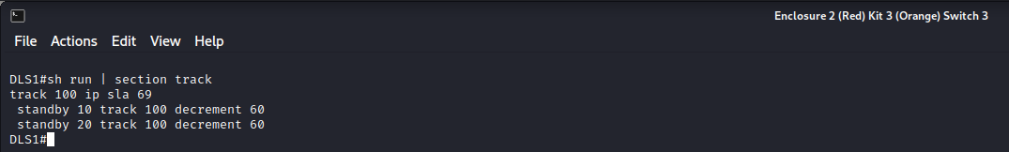

#### DLS2

## Routing

### sh ip route

These outputs show the routes set on DLS1, DLS2 and the gateway router. Gateway has a static route to the loopback0 interface which simulates the internet. DLS1 and DLS2 have static routes that point to their first hop addresses, being the end of their links to the gateway. This also displays the routes propagated by EIGRP which were created with the network commands. Loopback0 on the gateway was not advertised because it is supposed to simulate the internet.

#### GATEWAY

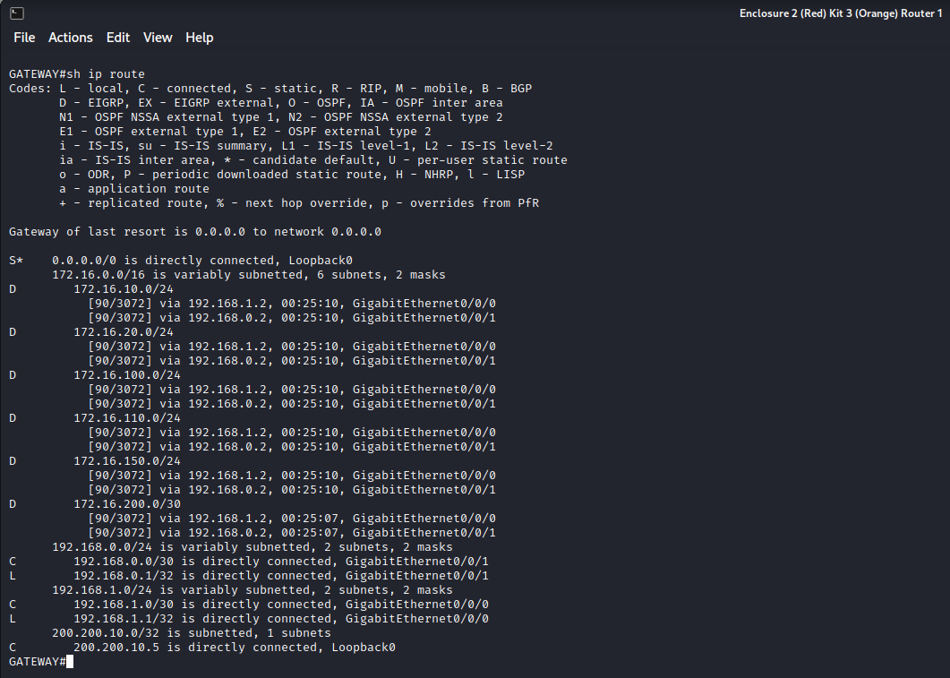

#### DLS1

#### DLS2

## DHCP

### sh ip dhcp snooping

These outputs show that DHCP snooping is enabled on ALS1 and ALS2’s physical ports for their EtherChannels. These ports are all set to trust DHCP information, but have rate limits set to 15 pps.

#### ALS1

#### ALS2

### sh run | section ip dhcp relay

These outputs show that DLS1 and DLS2 have been configured so that they trust all of their interfaces as sources of DHCP relay information.

#### DLS1

#### DLS2

## Port Security

### sh port-security

These outputs show that ALS1 Fa0/13-24 are configured for port security allowing a maximum of three MAC addresses to be learnt in the ‘MaxSecureAddr’ and to shut down if any more different MAC addresses are detected on those interfaces. ALS2 Fa0/18 is currently holding onto an address ‘CurrentAddr’ and with the ‘MaxSecureAddr’ being 1 it won’t allow any more MAC addresses to be added which if violated will go into protected mode.

#### ALS1

#### ALS2

## ACLs

### sh access-list

These outputs show the ACLs on DLS1, DLS2 and ALS1. This shows that ALS1 has an extended ACL called temp-host which is used for the temporary teaching staff. This ACL is used as a VACL. DLS1 has an ACL called STAFF_ACL which allows any device in the staff VLAN 10 to communicate with any device. DLS1 also has another ACL called STUDENT_ACL which denies access to the staff VLAN except for ICMP replies (staff might want to ping students). The STUDENT_ACL lets students communicate with any other device except for staff devices (except for echo reply). It would make sense for students to be denied access to the staff VLAN in a real world setting. The STUDENT_ACL and STAFF_ACL have been copied onto DLS2 so that DLS2 can enforce these ACLs incase DLS1 goes down.

#### ALS1

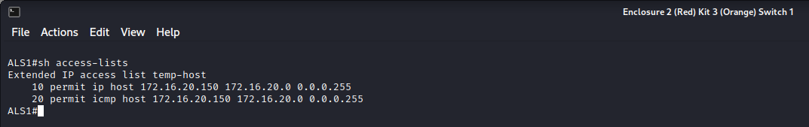

#### DLS1

#### DLS2

### sh ip int | include line | list

These outputs show which interfaces ACLs are applied to. It shows that on ALS1, the temp-host ACL is applied to Fast Ethernet 0/9. These also show that the STAFF_ACL has been applied to interface VLAN 10 and the STUDENT_ACL has been applied to interface VLAN 20 on both DLS1 and DLS2.

#### ALS1

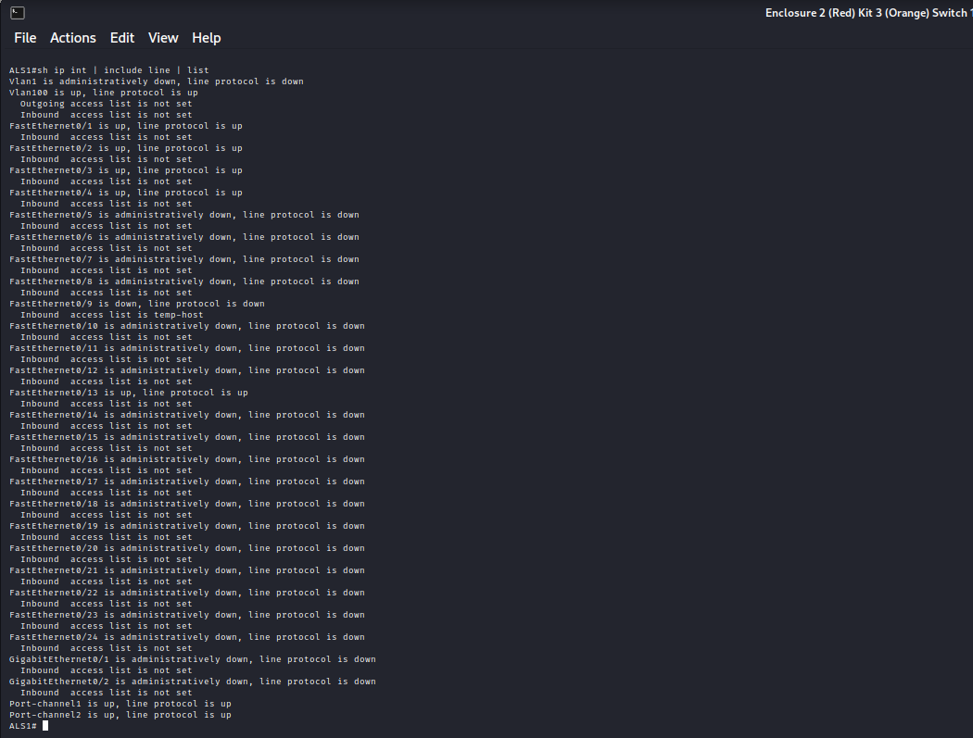DLS1

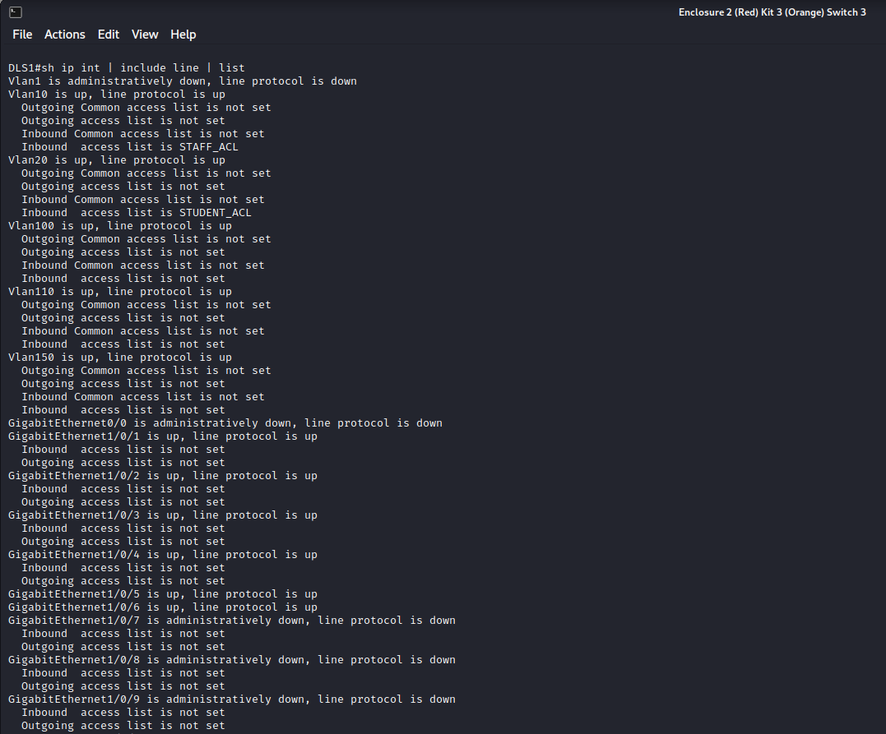

#### DLS2

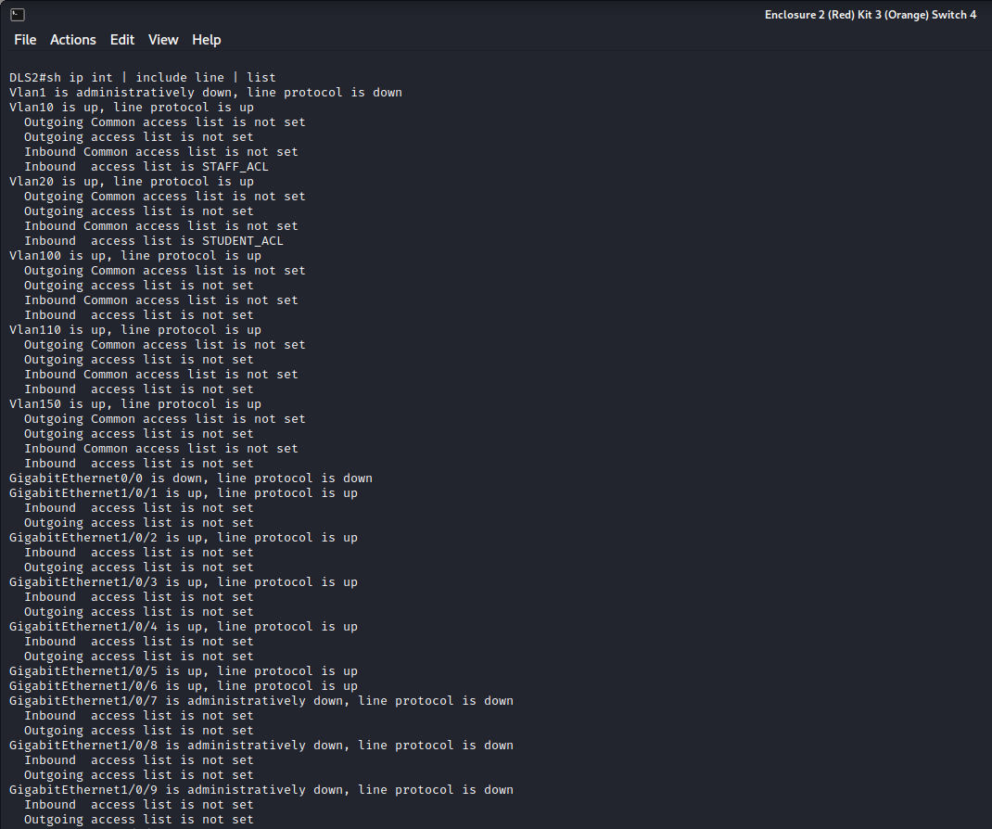

## VACL

### sh run | section vlan access-map

This output shows that a VACL has been configured using the temp-host ACL for the temporary staff member. It is made to drop packets that are destined for staff VLAN 10 if the source is from the temporary staff member’s IP address. If the source IP address is not the temporary staff member’s IP address, then packets will not be dropped and will be forwarded (assumes that others are regular staff members that are allowed normal access).

#### ALS1

### sh run | section vlan filter

This output shows that a VLAN filter was applied to block-temp which is a VACL used to block access to the staff VLAN but allow access to everything else for the temporary staff member. This shows that block-temp is only applied to VLAN 10.

#### ALS1

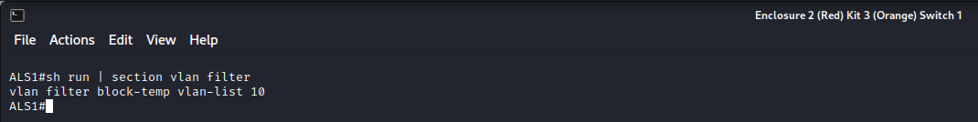

## SSH

### sh ip ssh

This output shows that SSH is enabled on the gateway router and it shows the keys.

#### GATEWAY

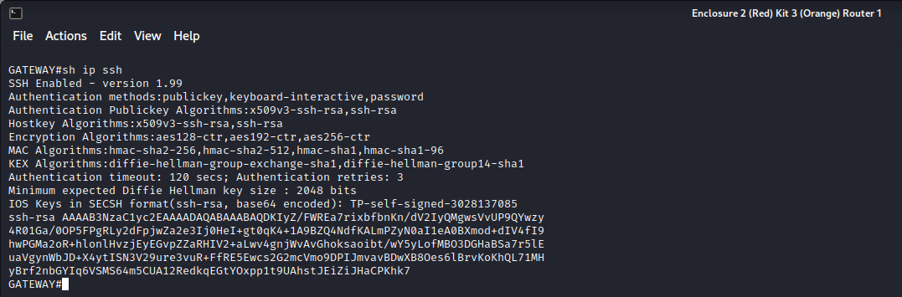

#### sh run | section line vty

This output shows that SSH is enabled on on line vty 0 4 and that a username and password is required to access it (login local).

GATEWAY

## NTP

### sh ntp status

This output shows that ALS1, ALS2 and DLS2 are set to getting their clock time from DLS1 using it’s IP address which is 172.16.100.2, which is set as the NTP master server. This allows all the switches to have their time synchronised with DLS1, which results in consistent time on all switches.

#### ALS1

#### ALS2

#### DLS1

#### DLS2

### sh ntp association

These outputs show that DLS1 is the NTP server that the switches are getting their clock time from. It shows information such as the offset and delay for each switch when receiving a time update. DLS1 shows the address 127.127.1.1 and reference clock as .LOCL. because it is the NTP master and it is not getting the time from another NTP server.

#### ALS1

#### ALS2

#### DLS1

#### DLS2

## Private VLANs

### sh vlan private-vlan

This output shows that ports from Gigabit Ethernet 1/0/15-17 are assigned to the isolated private VLAN and 1/0/18-20 are assigned to the community private VLAN. Both these PVLANs are associated with primary VLAN 150.

#### DLS2

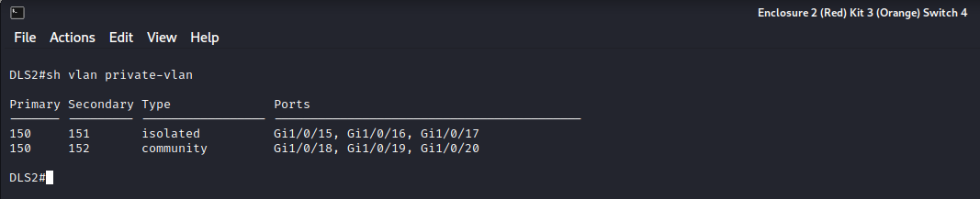

### sh vlan private-vlan type

This output shows the primary, isolated and community VLAN numbers.

#### DLS2

## Test connectivity to Internet

#### ping 200.200.10.5

These outputs show that ALS1 and ALS2 can send a ping to the simulated Internet on loopback0 on the gateway and receive a response back successfully.  
ALS1

#### ALS2

